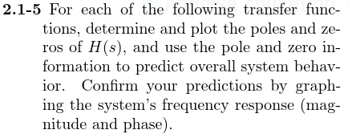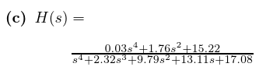

Using MATLAB,

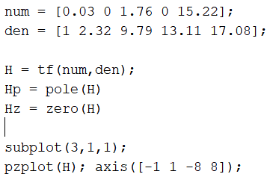

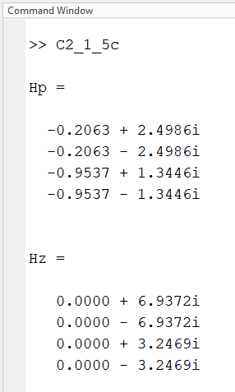

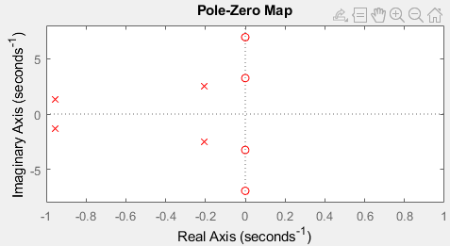

From looking at the P/Z Map we can see that

* As omega goes to infinity |H(s)| = 0
* There are some poles close to omega = 0 rad/sec (DC)

From this I would assume

* This transfer function has low pass-ish characteristics. Looking at the graph I would make a guess that it passes frequencies in the 0 – 2 rad/sec band
* Difficult to guess what type of phase response this T.F. just by looking at the P/Z Map

In MATLAB,

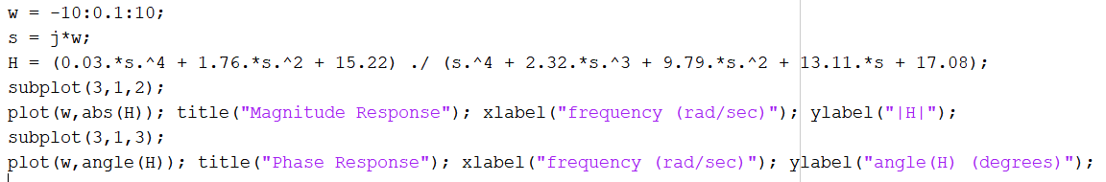

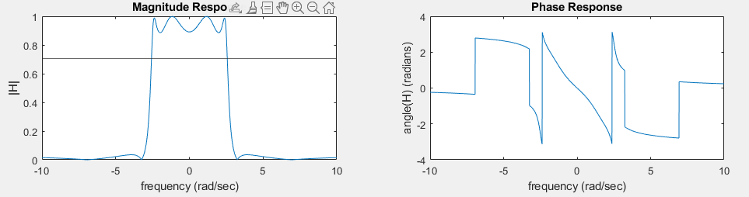

From these plots we can see that:

* T.F. is a low-pass filter. From its shape it looks epileptic
* Has a ½ power point at ±2.57 rad/sec. So, our guess of the pass band being from 0 🡪 2 rad/sec was a somewhat good estimate
* It appears the phase response in the pass band (-2.57 rad/sec 🡪 2.57 rad/sec) is somewhat close to linear. Plotting the first derivative of the phase response (seen on next page), we see the slope of phase is sticks close to -1 rad / (rad/sec) . This can help keep distortion less transmission in the pass band

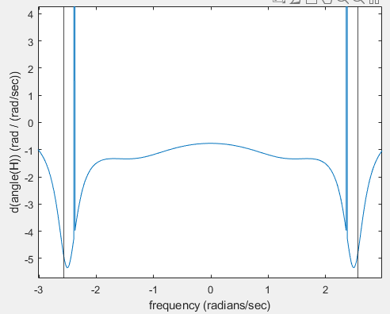

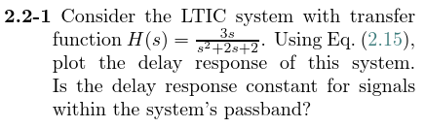



In MATLAB,

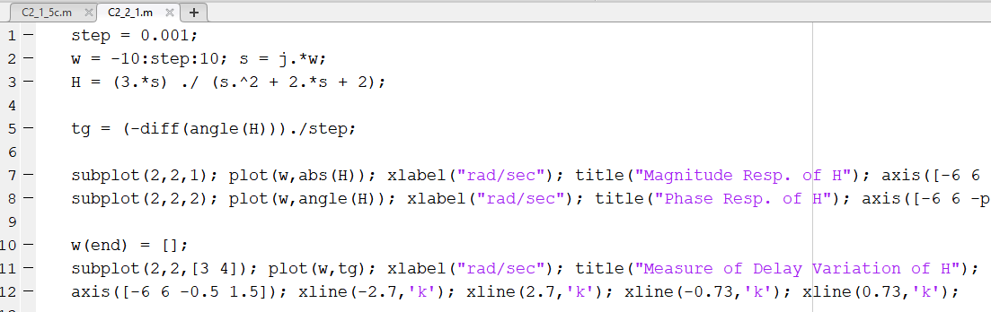

In the bottom plot we can see that this systems delay varies from a max of $1.2 \frac{rad}{{rad}/{sec}}$ to $0.33 \frac{rad}{{rad}/{sec}}$ over the pass band $\left(0.73 \frac{rad}{sec} to 2.7\frac{rad}{sec}\right)$. Therefore, this system **does not** have a constant delay response in the passband.

